

ESKİŞEHİR TECHNICAL UNIVERSITY

FACULTY OF ENGINEERING

**Kindergarten Management & Information System Mobile Applications**

Yağmur DOĞAN– Betülnaz HAYRAN -Batuhan KESİKBAŞ

A Bachelor of Science Project

Department of Computer Engineering

June 2022

**Kindergarten Management & Information System Mobile Applications**

by

**Yağmur DOĞAN (10963330588)**

**Betülnaz HAYRAN (28354853660)**

**Batuhan KESİKBAŞ (40573251614)**

Submitted in partial fulfillment of the requirements for the degree of Bachelor of Science in Computer Engineering is approved by the following scientific committee members.

**Date of Approval :**

**Member (Advisor) : Assistant Professor Dr. Sevcan YILMAZ GÜNDÜZ**

**Member : Assistant Professor Dr. Mehmet KILIÇARSLAN**

**Member : Assoc. Professor Dr. Mehmet KOÇ**

**ABSTRACT**

It’s been decided to work on Kindergarten Management and Information System mobile applications using Flutter-Dart and Firebase. It has created two different mobile applications with different abilities on the system. The two users are Management and Parents. Several functions and sections have been added for the referred users. Such as schedule, messaging section, meal menus, photos section, medicines that the child uses, payments for the kindergarten itself or the extra events -as showing if it’s paid or not, student list for the teacher and game section for the parent section in order for the parent to play interactive games with their child. For the user’s abilities, Management users can add, delete, and edit all the data from the sections as study plan, messaging section, meal menus, photos section and finally Parents can only add data into the sections as messaging section, the medicines that the child uses. The main structure idea for the project is basically as mentioned above.

The main aim was to make a simple mobile application between school, parent, and teacher so that the tracking information about the child can be made easier to maintain and to make communication between parents and management easier. The project aimed to make parents aware of their children's study plans, meal details, and activities. It also aimed to make a message section for parents and management to communicate with each other. For instance, when a parent desires to notify the teacher about an issue, it will be way easier to just open the application and send a message to the administration through the application itself. Medicines section aimed to make the kindergarten aware of children's health situations. The payment section aimed to show information about the payment of the parent. The photo section has the photos of the children. The aims mentioned above have been achieved.

**Keywords**: Mobile Application, Kindergarten Management System, Parent and Teacher’s Communication, Flutter, Firebase.

**ACKNOWLEDGEMENT**

For the support of the 13. Project Fair to our career steps, we would like to thank our Honorable Rector Professor Dr. Tuncay DÖĞEROĞLU and the Honorable Dean of Engineering Faculty, Professor Dr. Onur KAYA.

We would like to thank our Head of Department Professor Dr. Serkan GÜNAL for their presence whenever we need help.

We would like to thank our advisor Assoc. Professor Sevcan YILMAZ GÜNDÜZ for their help and support at all concerns, also giving us the idea of our project and showing us the appropriate way and we would like to thank to Özgür ÖZŞEN for the support as our lecturer of Mobile Programming.

**CONTENTS**

**Page**

**ABSTRACT** **3**

**ACKNOWLEDGEMENT** **4**

**CONTENTS** **5**

**LIST OF FIGURES** **7**

**1. INTRODUCTION** **8**

1.1 Login Section 8

1.2 Menu Section 8

1.3 Health Section 8

1.4 Messaging Section 9

1.5 Payment Section 9

1.6 Food Section 9

1.7 Photos Section 9

1.8 Student List Section 10

1.9 Schedule Section 10

1.10 Games Section 10

1.11 Location Section 10

1.12 Drawer Section 11

1.13 Authentication Section 11

**2. USER BINDING** **12**

**3. SCREENSHOTS OF THE PAGES** **13**

3.1 Login Section 13

3.2 Menu Section 14

3.3 Health Section 15

3.4 Messaging Section 16

3.5 Payment Section 17

3.6 Food Section 18

3.7 Photos Section 19

3.8 Student List Section 20

3.9 Schedule Section 21

3.10 Games Section 22

3.11 Location Section 23

3.12 Drawer Section 24

**X. CONCLUSIONS** **25**

**REFERENCES** **26**

**LIST OF FIGURES**

**Page**

Figure 3.1. Login Pages 13

Figure 3.2. Menu Pages 13

Figure 3.3. [Health](https://docs.google.com/document/d/1_elQiuJbwDdKPs916T97NUswBjoZ0gbAokfp9FkXZwg/edit#heading=h.4d34og8) Pages 14

Figure 3.4. [Messaging](https://docs.google.com/document/d/1_elQiuJbwDdKPs916T97NUswBjoZ0gbAokfp9FkXZwg/edit#heading=h.2s8eyo1) Pages 14

Figure 3.5. [Payment](https://docs.google.com/document/d/1_elQiuJbwDdKPs916T97NUswBjoZ0gbAokfp9FkXZwg/edit#heading=h.4d34og8) Pages 15

Figure 3.6. [Food](https://docs.google.com/document/d/1_elQiuJbwDdKPs916T97NUswBjoZ0gbAokfp9FkXZwg/edit#heading=h.2s8eyo1) Pages 15

Figure 3.7. [Photos](https://docs.google.com/document/d/1_elQiuJbwDdKPs916T97NUswBjoZ0gbAokfp9FkXZwg/edit#heading=h.4d34og8) Pages 16

Figure 3.8. [Student List](https://docs.google.com/document/d/1_elQiuJbwDdKPs916T97NUswBjoZ0gbAokfp9FkXZwg/edit#heading=h.2s8eyo1) Pages 16

Figure 3.9. [Schedule](https://docs.google.com/document/d/1_elQiuJbwDdKPs916T97NUswBjoZ0gbAokfp9FkXZwg/edit#heading=h.4d34og8) Pages 17

Figure 3.10. [Games](https://docs.google.com/document/d/1_elQiuJbwDdKPs916T97NUswBjoZ0gbAokfp9FkXZwg/edit#heading=h.2s8eyo1) Pages 17

Figure 3.11. [Location](https://docs.google.com/document/d/1_elQiuJbwDdKPs916T97NUswBjoZ0gbAokfp9FkXZwg/edit#heading=h.2s8eyo1) Pages 18

Figure 3.12. [Drawer](https://docs.google.com/document/d/1_elQiuJbwDdKPs916T97NUswBjoZ0gbAokfp9FkXZwg/edit#heading=h.2s8eyo1) Pages 18

1. **1. INTRODUCTION**

School, parents, and teachers will be relieved with these following sections. Every section has different user interfaces and functions. Pages and sections are explained below.

**1.1 Login Section**

This login page is designed to be private, so we do not want anyone to be able to sign up who is not related to the kindergarten. So if the parents or teachers want to login they need to contact someone in authority.

In Firebase, by using email and password, sign up can be done easily. Emails are unique so there cannot be any more users related to that email. Once sign up is done, the user can login and be directed to the main menu. Our authentication will warn the user if the email or password is incorrect. If the user forgot their password, they can click ‘Forgot Password’ to reach the phone number or they can click ‘CLICK HERE’ to reach the email of the authorized someone. After first login, the unique user collection is created with email and password[1][2].

**1.2 Menu Section**

In the menu section, firstly there is our logo and the motto of our kindergarten. Then there are cards for each section of the applications. The cards contain the icon and the title of the section. When clicked on the section that the user chooses, the user will automatically be directed to that section[1].

**1.3 Health Section**

In the health section of the parent, parents can add, delete, or edit a medicine name and the usage of it.

In the health section of the administration, the administration can add,delete,or edit a medicine name and the usage of it. Purpose of this is that if the parent doesn’t have a mobile application, it can notify the administration to add them to the system. The administration can see the name of the child and the health information of it. When adding a medicine, the parent does not write the child’s name. The Health section uses User Binding to write the child’s name to the administration’s screen automatically[1].

**1.4 Messaging Section**

In the messaging section, Firebase technology has been used. There are two users. When a parent writes a message it appears on the right side of the screen and has a blue background. When an administration writes a message it appears on the left side of the screen and has a red background. Whenever a user writes a message it will update both parent’s and administration’s screens immediately[1].

**1.5 Payment Section**

In the payment section of the administration, administration can add, delete or edit the payment information. The payment information is the name of the kid, payment details, cost and payment status. When the administration enters the name of the kid, the information of that kid will be updated in the parent's application’s payment section. In the parent’s payment section, the parent can only view the payment information[1].

**1.6 Food Section**

Food Menu can be viewed by swiping right or left. Our research showed that in kindergartens there is a snack break instead of dinner. These foods can be edited by the management by clicking on the texts of the name of days. Parents cannot edit these pages. There is an information part that can give information about rules or how this cafeteria works[1][3].

**1.7 Photos Section**

In the parent’s gallery section, the photos can be only viewed and downloaded by the parent. If it is the first time of downloading, the app asks permission for gallery access. Firebase Storage has been used to store these photos.

Administration can delete and/or add photos to the gallery section. The Firebase Storage will immediately refresh it and the parent’s gallery section will update itself at the same time too[1].

**1.8 Student List Section**

This page only belongs to management’s application. By this page the management can view every student in the kindergarten with their photo, name, class and the phone number of their parents[1][3].

**1.9 Schedule Section**

Research showed that in kindergartens the lesson plan always stays the same so the page does not have any editing tools on it. If needed it can be changed easily[3].

**1.10 Games Section**

The games section contains two games. One is the ‘Color game’ and the other one is the ‘Tic Tac Toe’ game.

The Color Game has six fruits that are different colors from each other and the colors that are randomly placed each time the user hits the refresh button. There is also a score part in the app bar of the Color Game section. When the user drags the fruit to its matched color, the fruit is replaced with a tick icon, the fruit part will write ‘correct’ to screen and score increases by one point. If the fruit and the color does not match the dragged icon will set to its original place and the score will not change.

The Tic Tac Toe game starts with hitting the squares that the user wants to leave a sign on. The signs are ‘X’ and ‘O’. There are three results. ‘X wins’, ‘O wins’ and ‘Draw’[1][4].

**1.11 Location Section**

This section can be reached from the drawer. By clicking location, the user will be directed to the Google Maps that shows the location of the Computer Engineering at Eskişehir Technical University. This location can be changed by changing a small part of the code[1].

**1.12 Drawer Section**

Every section has a drawer, and the drawer contains every section. Drawer contains direct links to the main menu, student list, health, messaging, food menu, photos, schedules, location, game menu, and log out[1][4].

**1.13 Authentication**

Authentication part contains the connection code between Firebase and the application. The code contains the necessary parts about login and logout. When the user signs in, the unique id is connected to that email and password. Sign out provides us to sign out safely and we need to log in the application again[2].

**2. USER BINDING**



As in the applications, parents can only see the information of their own child. Also, the messaging section has to be between the unique parent and the administration. For that case, user binding has been used.

The logic behind binding users is to get a unique id for the current user from the database and bind it to the information they have given to the system.

**3. SCREENSHOTS OF THE PAGES**

Screenshots of the pages and sections are shown below. Blue pages belong to the parent's application and the red pages belong to the administration's application.

**3.1 Login Section**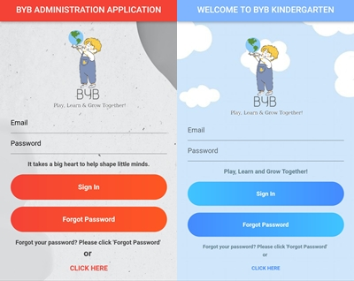

**Figure 1. Login Pages**

In the login pages user logs in to the system using their information and if the required areas do not include the accurate information, FireBase won’t let them login[1][3].

**3.2 Menu Section**

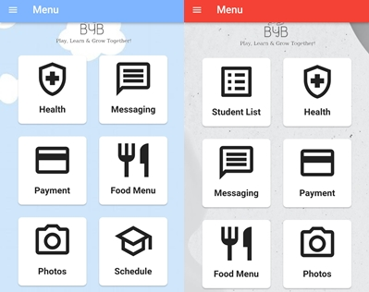**Figure 2. Main Menus**

In the main menu pages, user can see the menu cards and by tapping them user can get directed to the related page[3].

**3.3 Health Section**

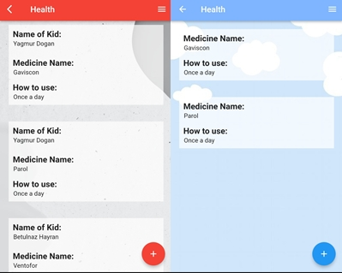**Figure 3. Health Sections**

In the health section parent or administration can add delete or edit data. Please note that the parent can only see their own child’s information while administration sees all children’s information[1].

**3.4 Messaging Section**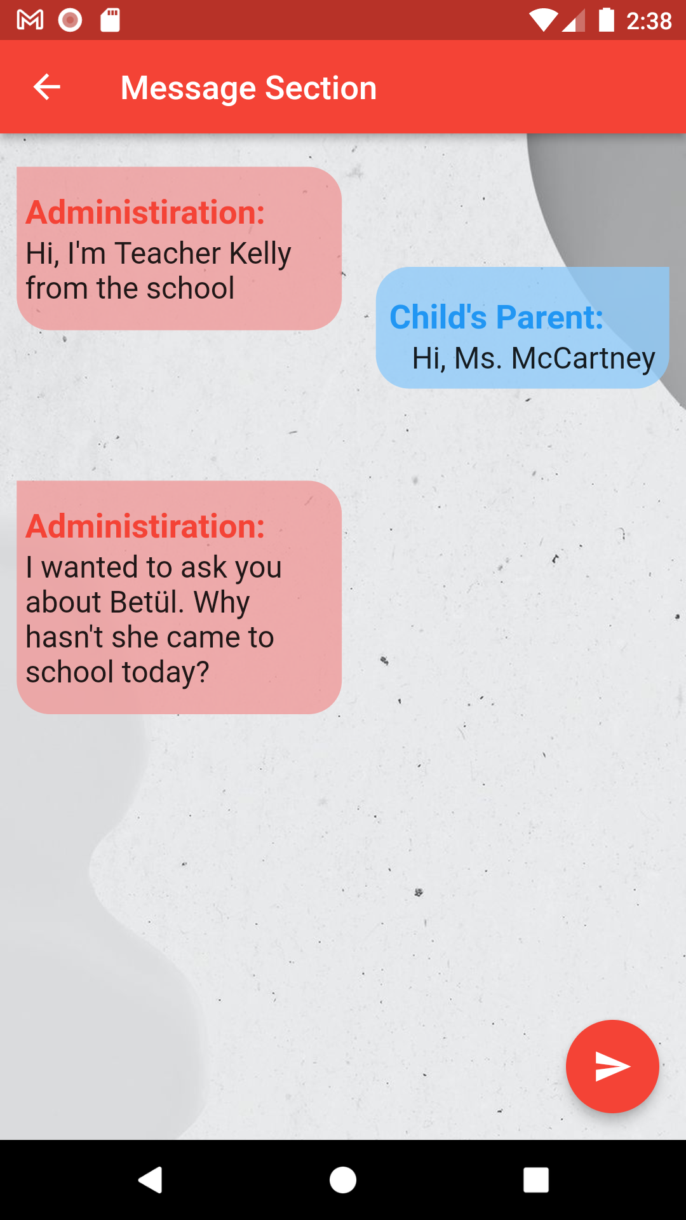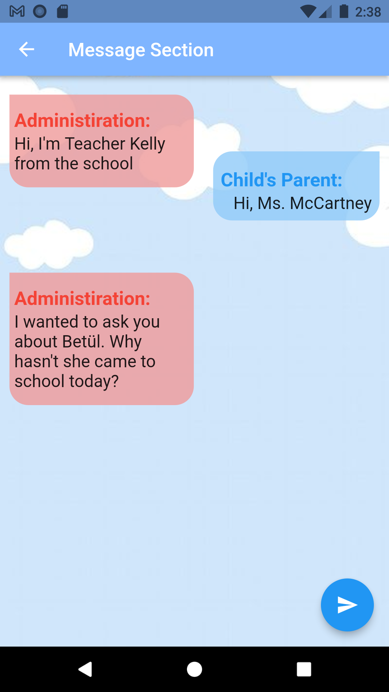

**Figure 4. Messaging**

In the messaging section, parent and administration can send messages to each other[1].

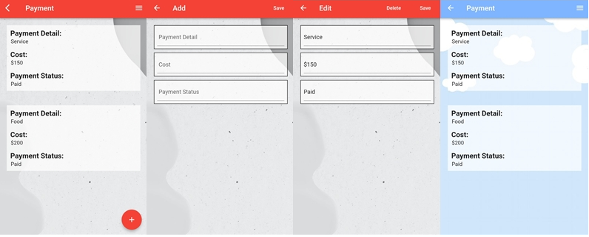**3.5 Payment Section**

**Figure 5. Payment**

In the payment section administration can add delete or edit data. Please note that the parent can only see their own child’s information while administration sees all children’s information. Also, this page does not include any transaction, but it displays the payment status[1].

**3.6 Food Section**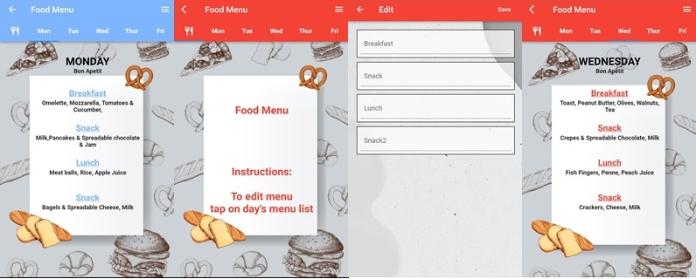

**Figure 6. Food Menu**

In the food menu section parent can see weekly menu while the administration can edit the menu by tapping on them[1][3].

**3.7 Photos Section**

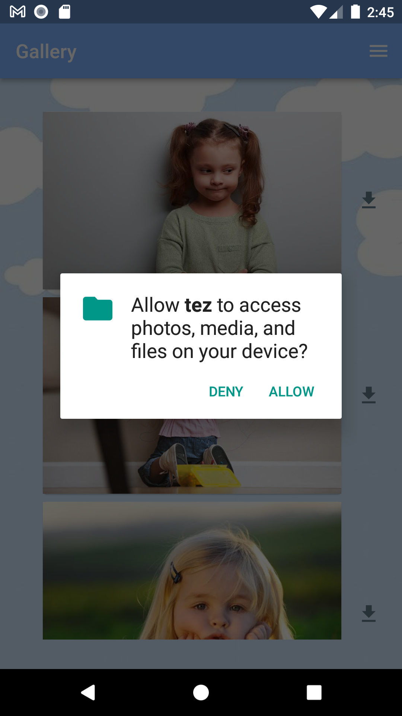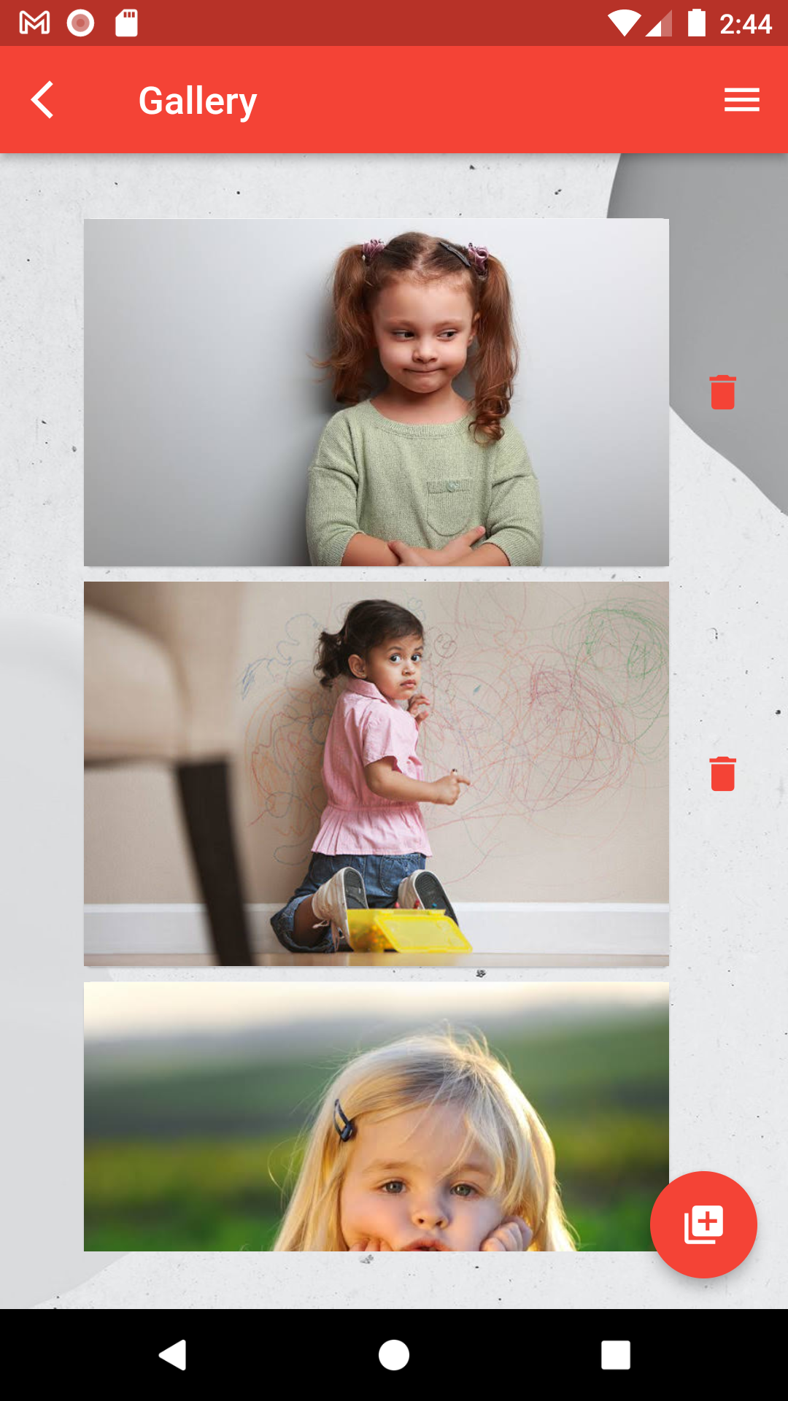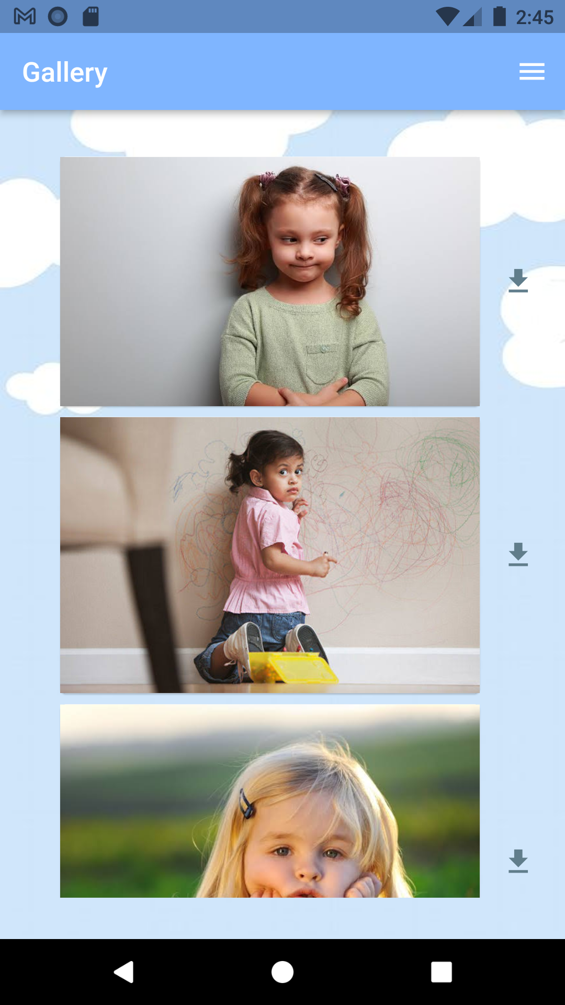

**Figure 7. Photos**

In the photos section, parent can see the uploaded photos of the child, also can download them by giving permission, while administration uploads images[1][3].

**3.8 Student List**

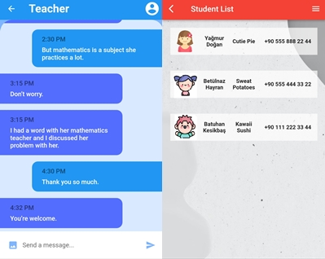

**Figure 8. Student List**

In Student list, administration can see their students with the information of the name, photo, class and contact number[1].

**3.9 Schedule Section**

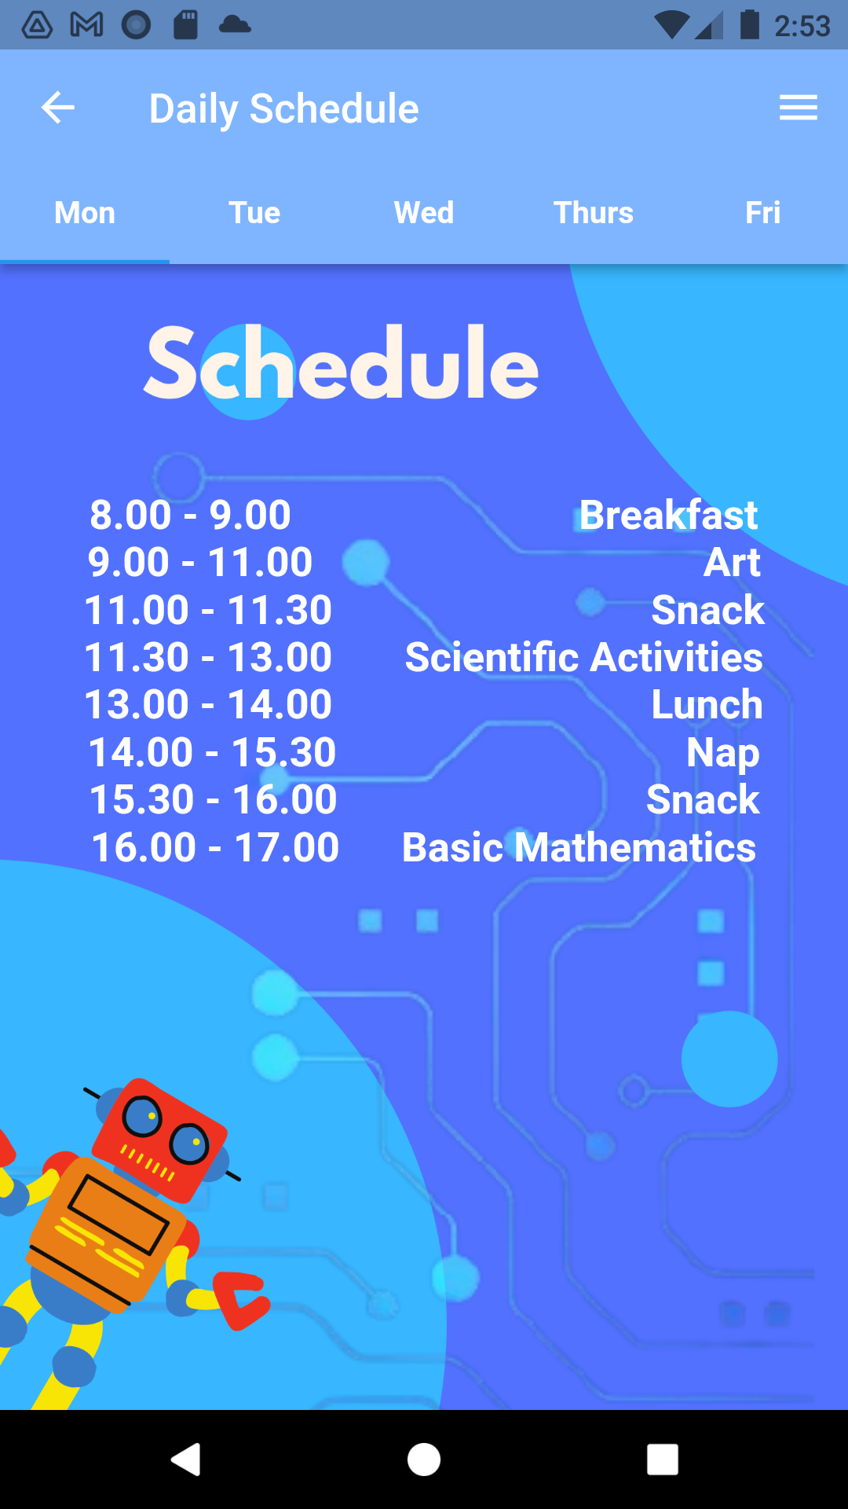

**Figure 9. Schedule**

In the schedule page, parent can see the schedule of the year[4].

**3.10 Games Section**

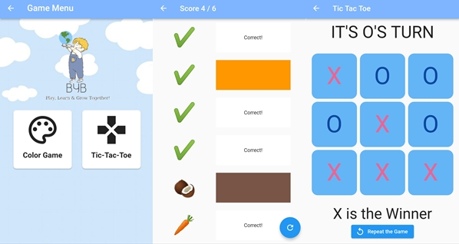**Figure 10. Games**

In the games page there are 2 games. The first one is the color game, and the other one is the Tic-Tac-Toe. It has been aimed the children to reinforce the things that s/he has learned at school. And by the Tic-Tac-Toe game, it has been aimed the parent to play and spend time together with their child[4].

**3.11 Location Section**

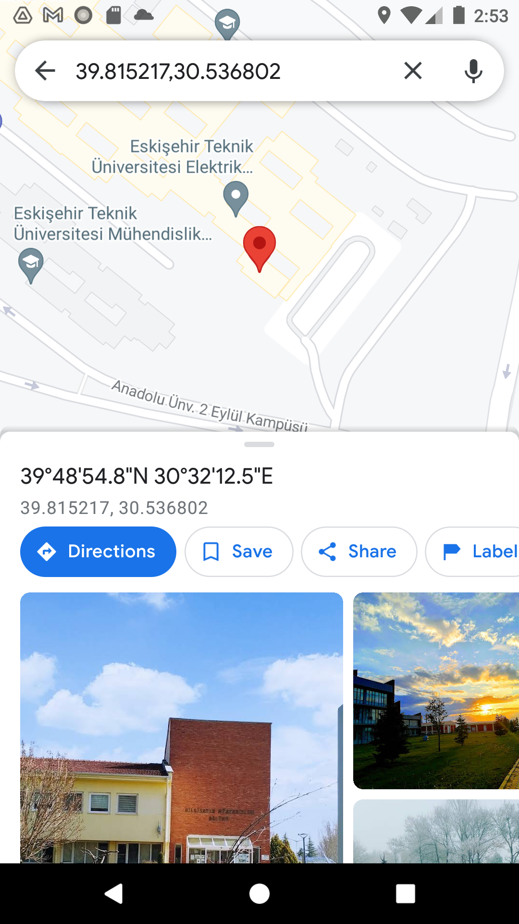

**Figure 11. Location**

In the drawer, user can reach the location of the kindergarten. Application redirects the user to Google Maps and user can use the location to reach to the school[1].

**3.12 Drawer Section**

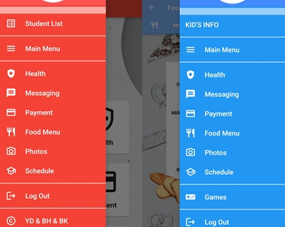

**Figure 12. Drawer**

In the drawers, user can see all the menu items in a list, and by tapping to them, user can get redirected to the related page[4].

1. **4. CONCLUSIONS**

In conclusion, the amount of paperwork of the kindergarten has been reduced and digitized. As the main aim was to operate data by using mobile applications, it can be said that it has been achieved. Interactions and communication between the school and parents have been made easier and faster.

**5. REFERENCES**

1. <https://pub.dev>

Reached during the project, from January to June.

1. <https://firebase.google.com/docs/auth>

Reached during the project, from January to June.

1. Özşen, Özgür, Mobile Programming 2 Lecture Notes, 2022

Reached during the project, from January to June.

1. <https://flutter.dev/>

Reached during the project, from January to June.